My Healthy Eating Plan Name: Supported by: Week beginning:

My diet goals |  | Monday | Tuesday | Wednesday | Thursday | Friday | Saturday | Sunday
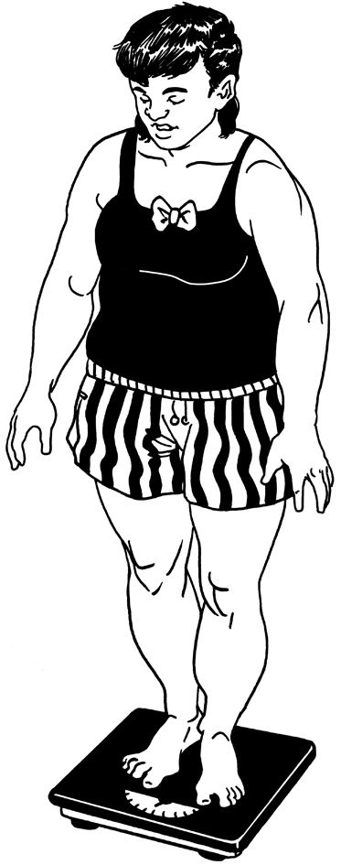  My ideal weight  How much I weigh  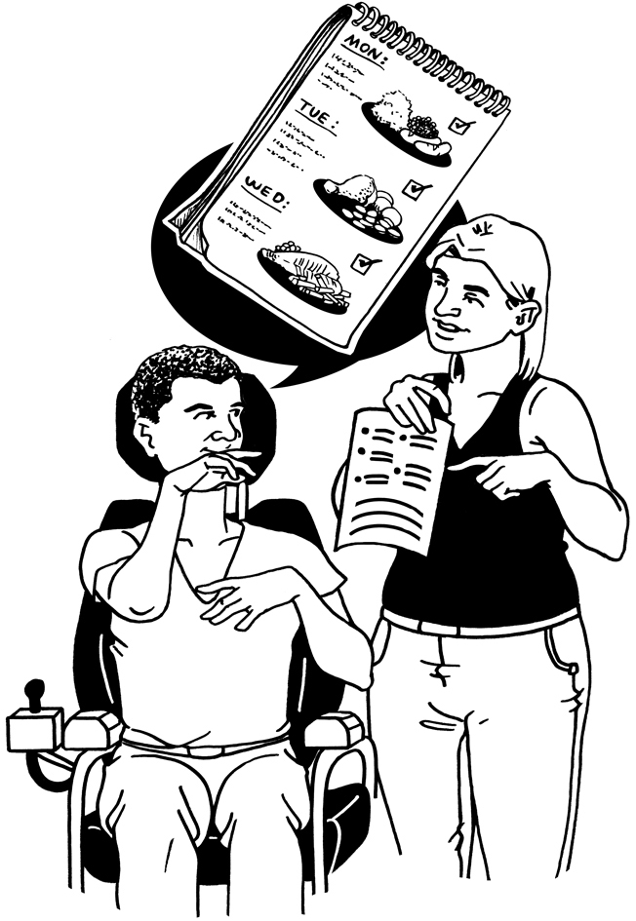  I will try to eat ___  Portions of Fruit or  Veg a day  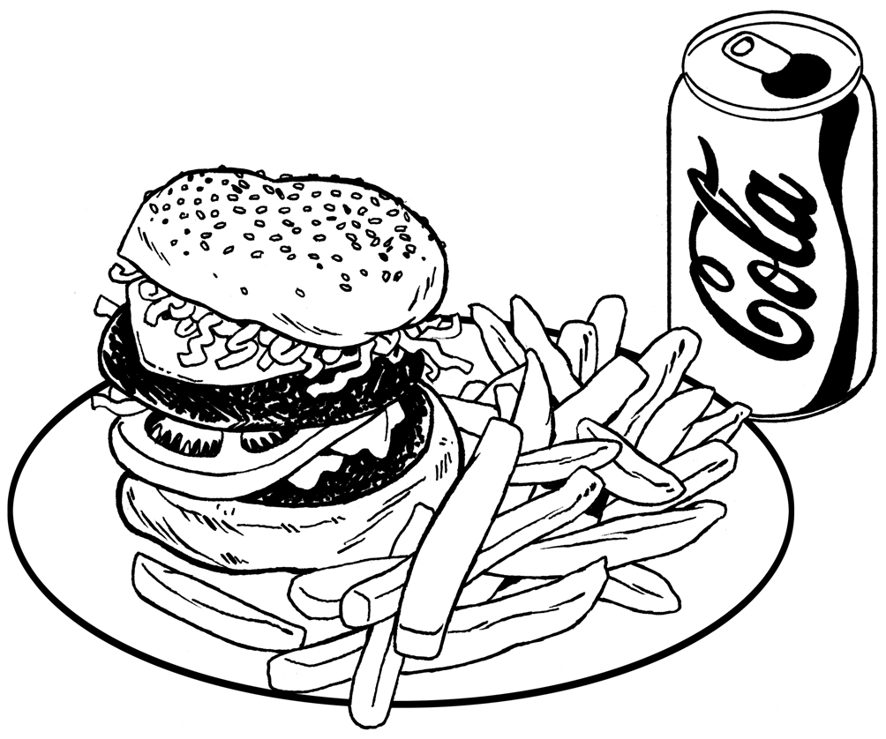  I will try to eat junk  food only __ times  a week.  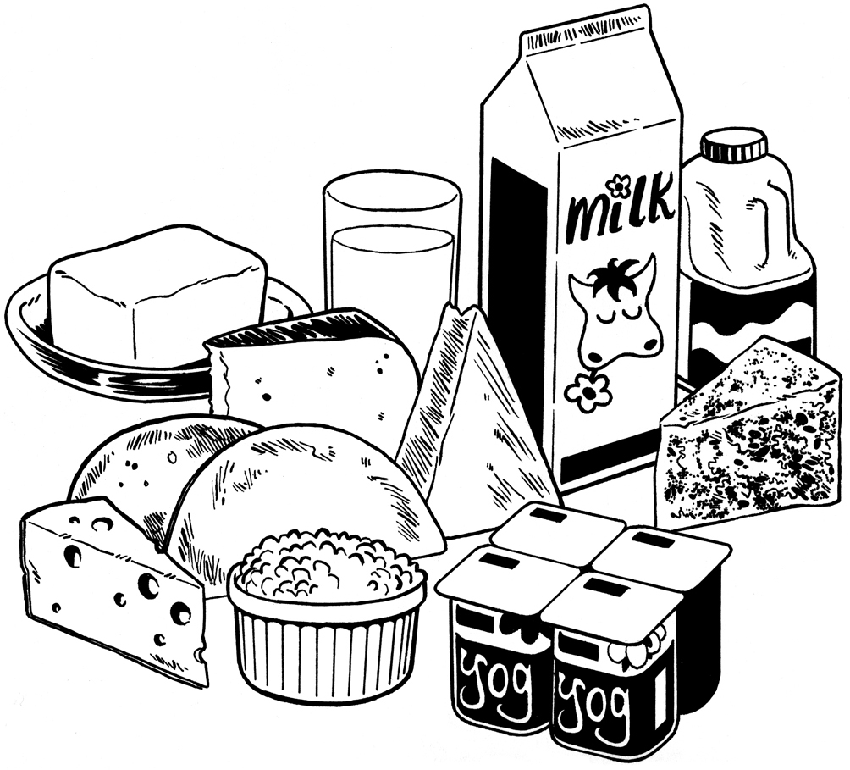  x  My Dietary requirements      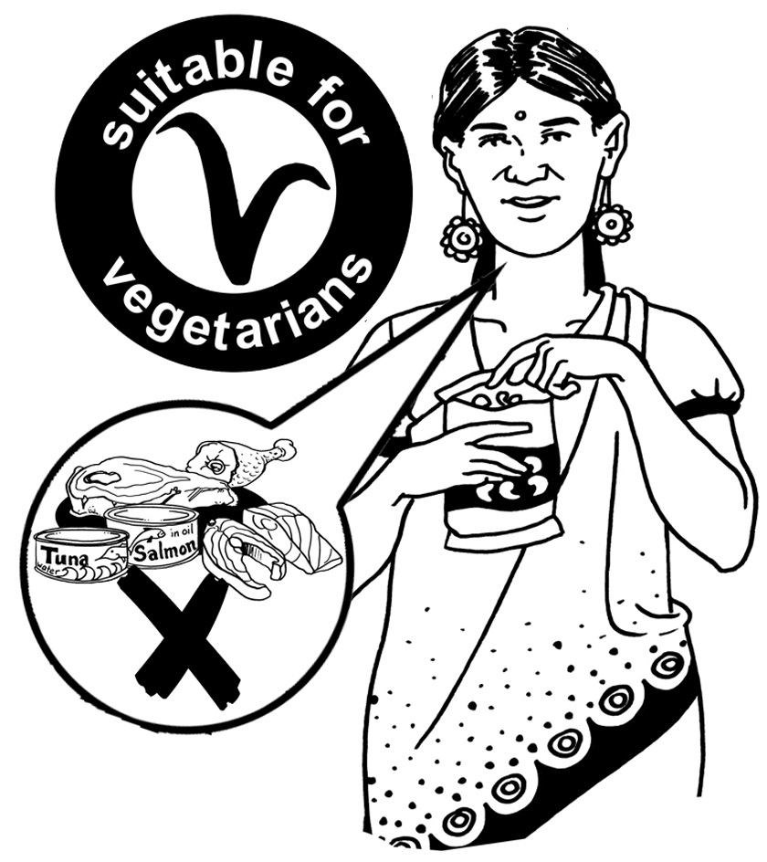  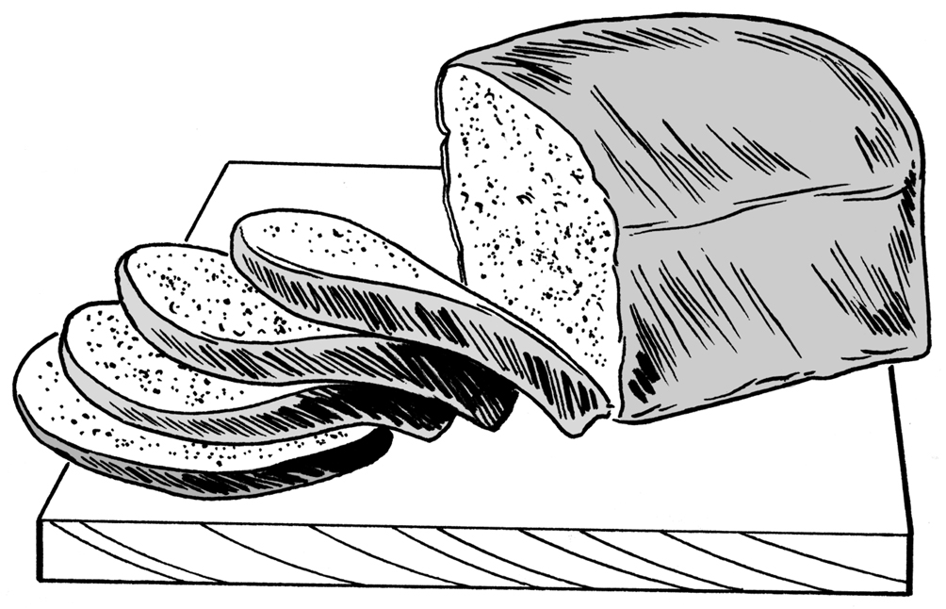  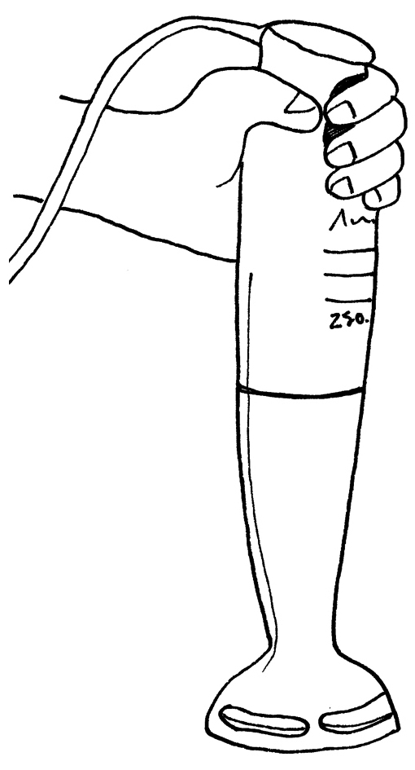  x  No solids  Any other: ______________  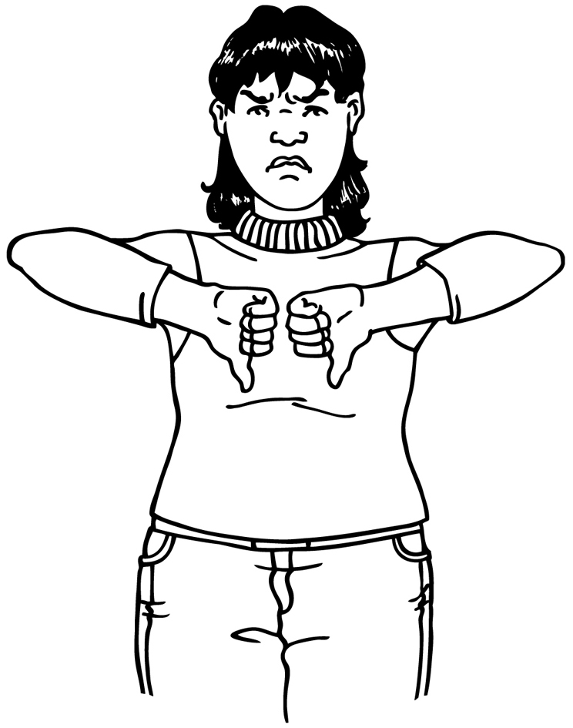  Foods that I do not  like: | Breakfast
 | Lunch
 | Dinner
 | Treats
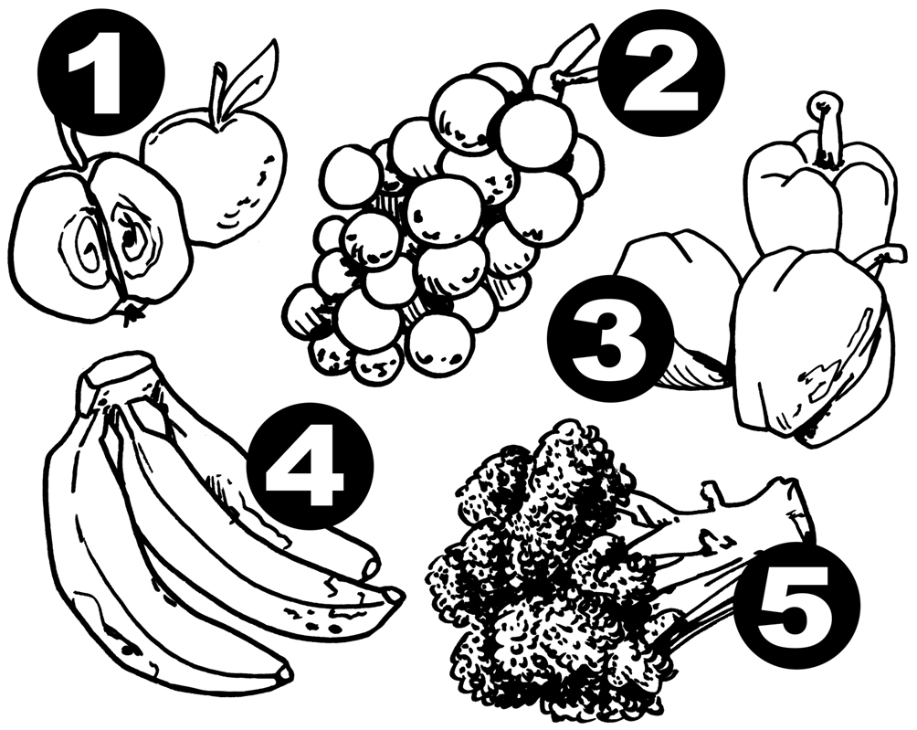  My ‘5 a Day’Score  Mark down how many  portions you have  had each day. |  | 